Decision Tree

**Objective:**

The objective of this assignment is to apply Decision Tree Classification to a given dataset, analyse the performance of the model, and interpret the results.

**Tasks:**

1. Data Preparation:

Load the dataset into your preferred data analysis environment (e.g., Python with libraries like Pandas and NumPy).

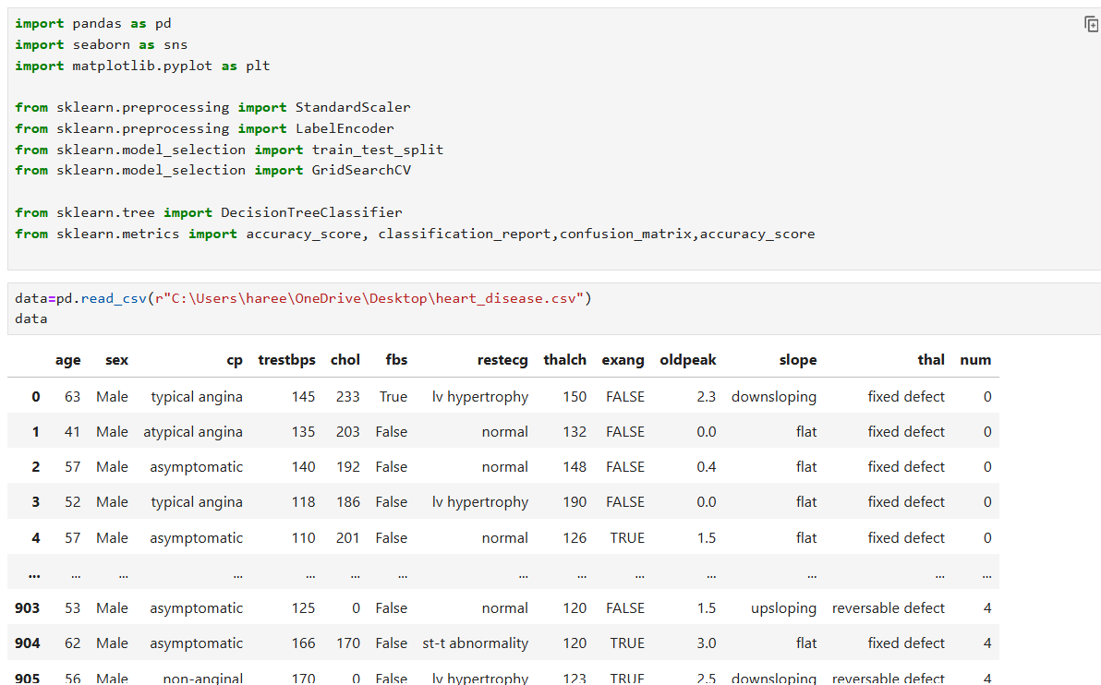

**2. Exploratory Data Analysis (EDA):**

Perform exploratory data analysis to understand the structure of the dataset.

Check for missing values, outliers, and inconsistencies in the data.

Visualize the distribution of features, including histograms, box plots, and correlation matrices.

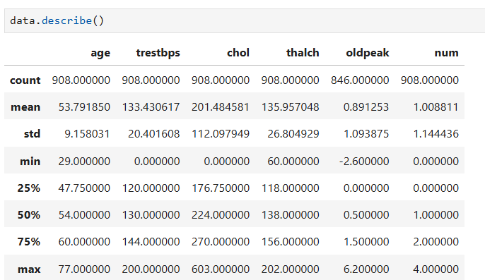

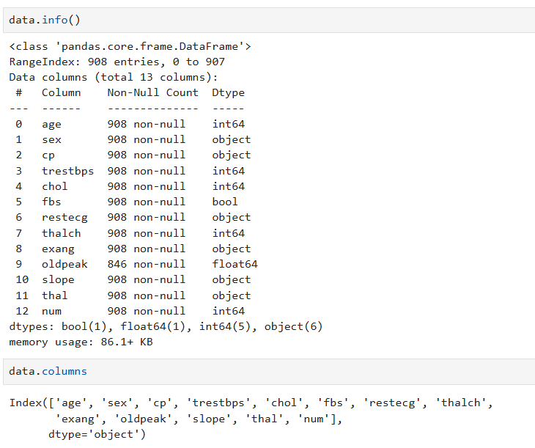

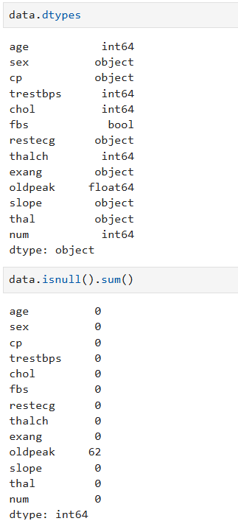

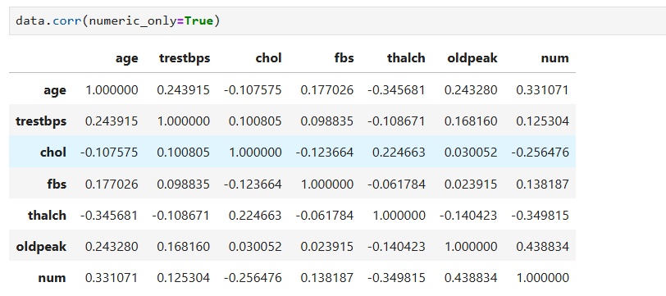

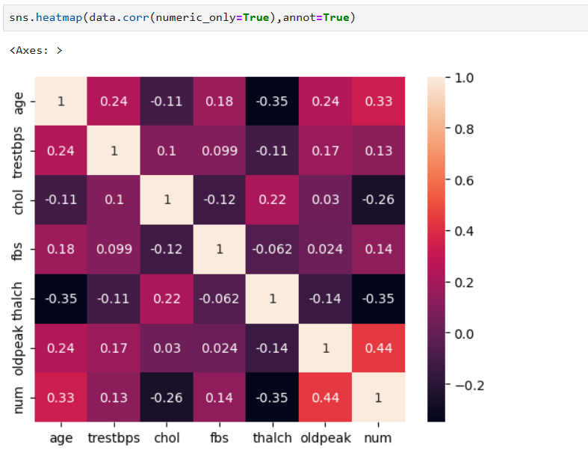

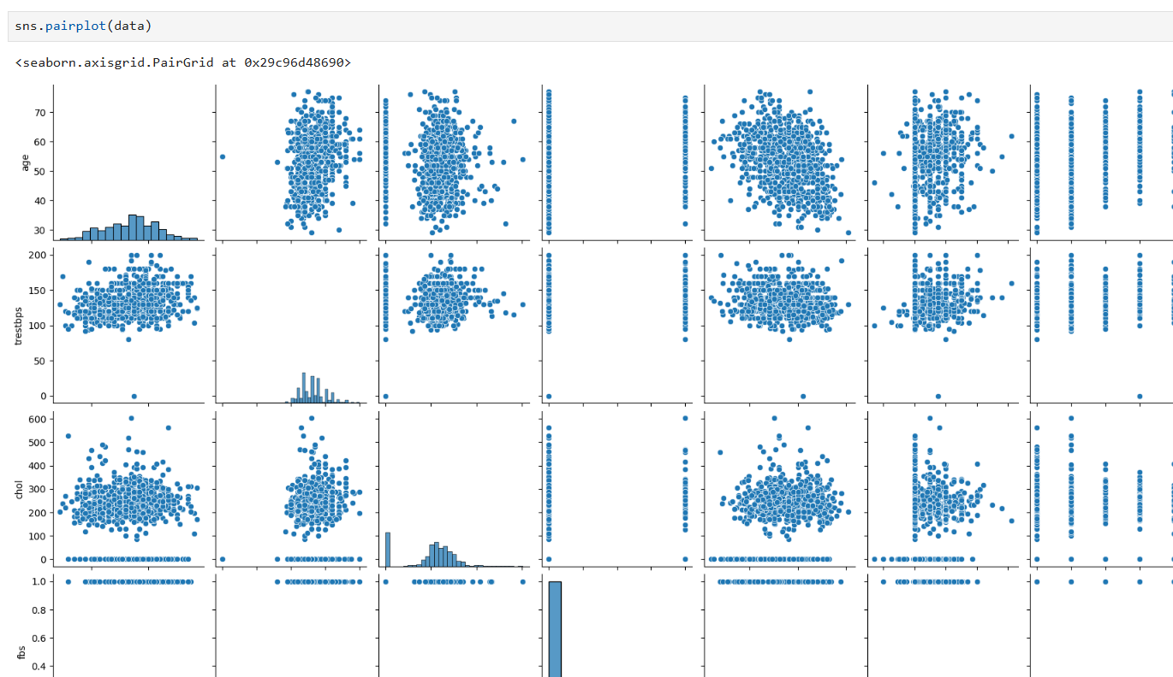

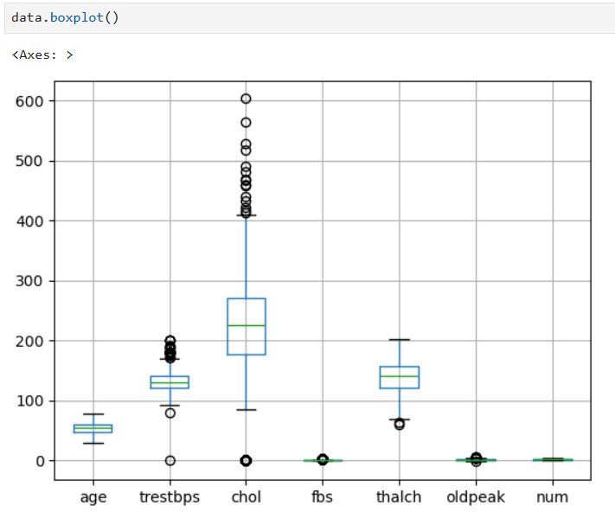

**3. Feature Engineering:**

If necessary, perform feature engineering techniques such as encoding categorical variables, scaling numerical features, or handling missing values.

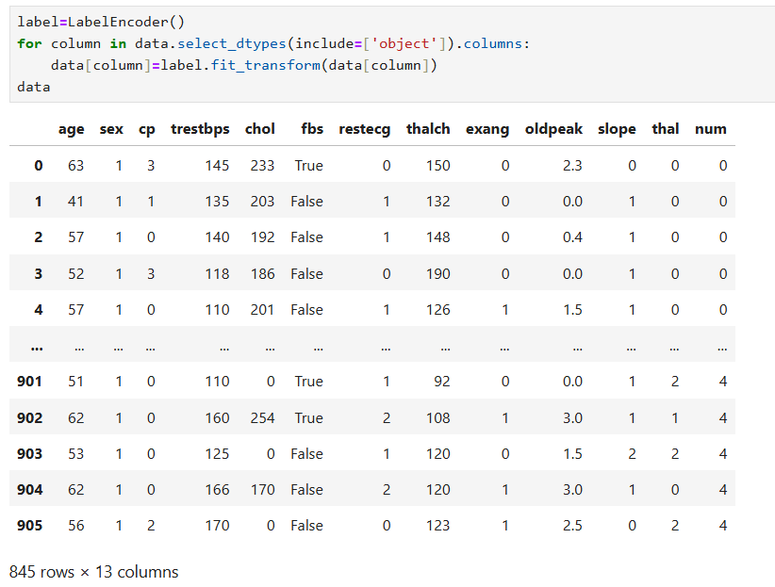

**4. Decision Tree Classification:**

Split the dataset into training and testing sets (e.g., using an 80-20 split).

Implement a Decision Tree Classification model using a library like scikit-learn.

Train the model on the training set and evaluate its performance on the testing set using appropriate evaluation metrics (e.g., accuracy, precision, recall, F1-score, ROC-AUC).

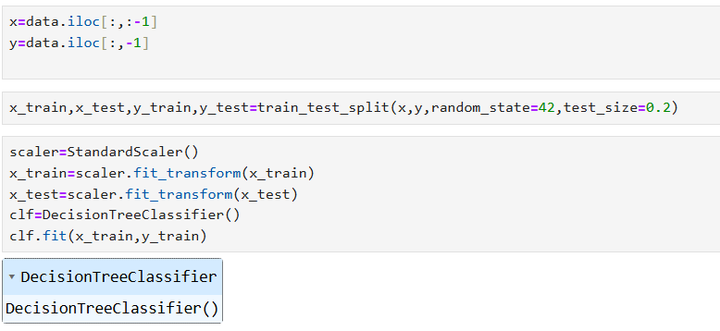

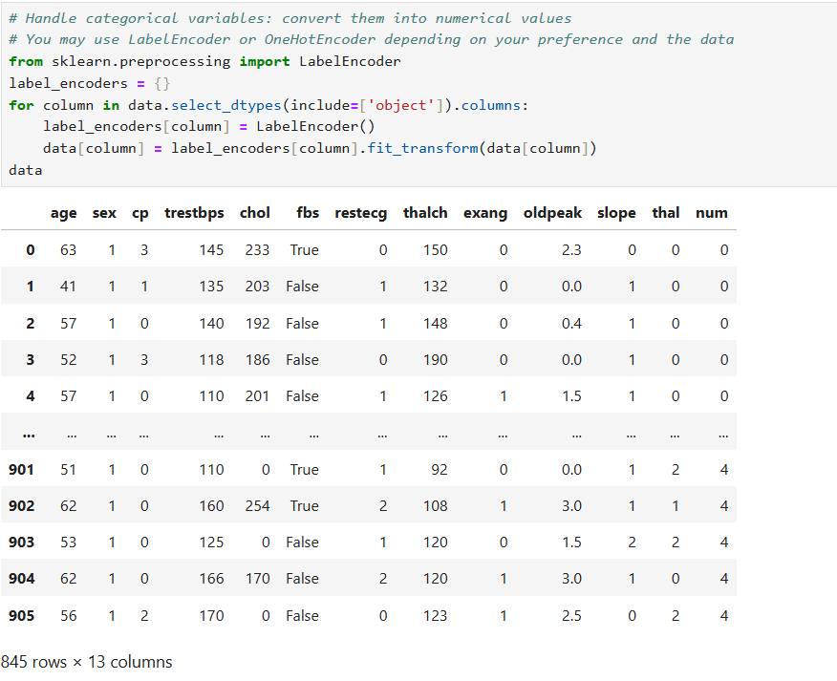

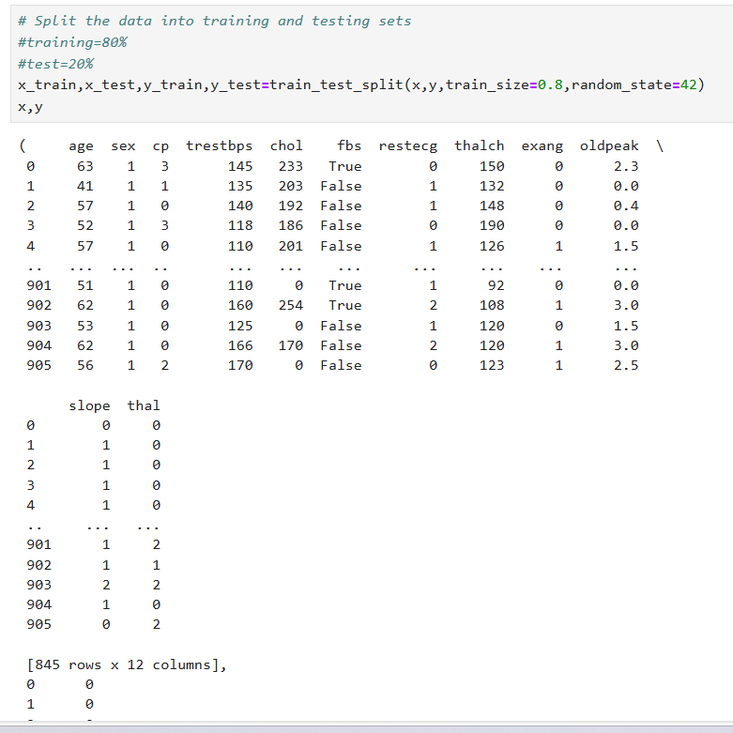

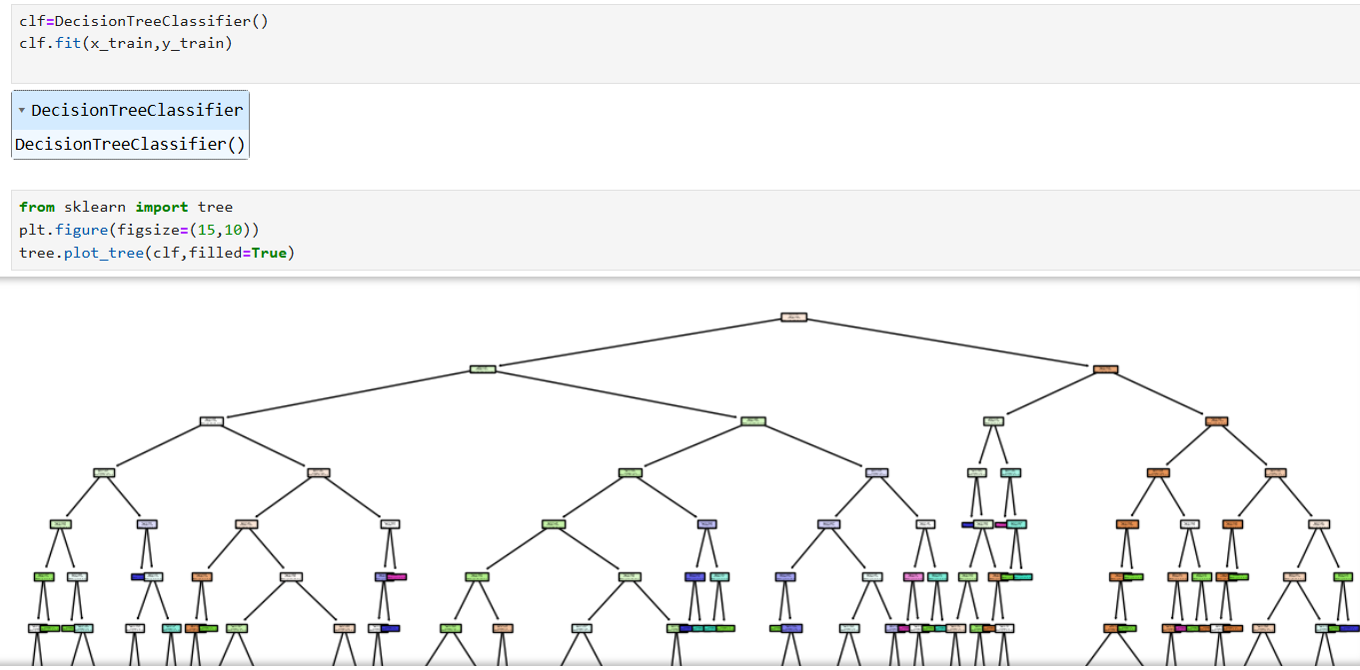

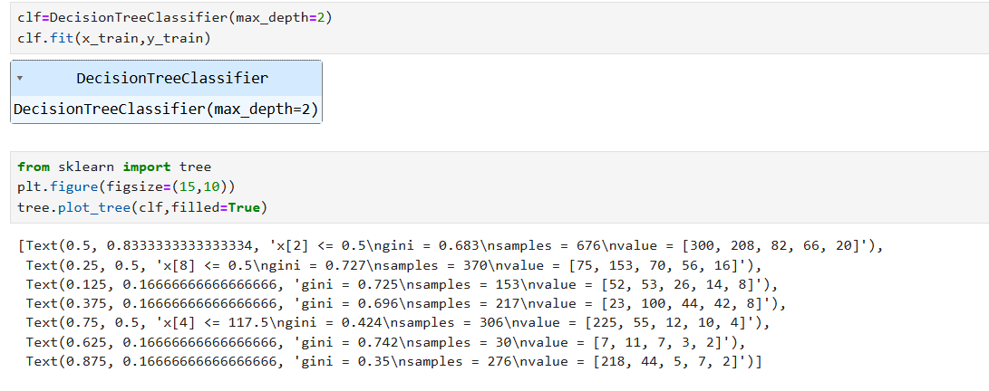

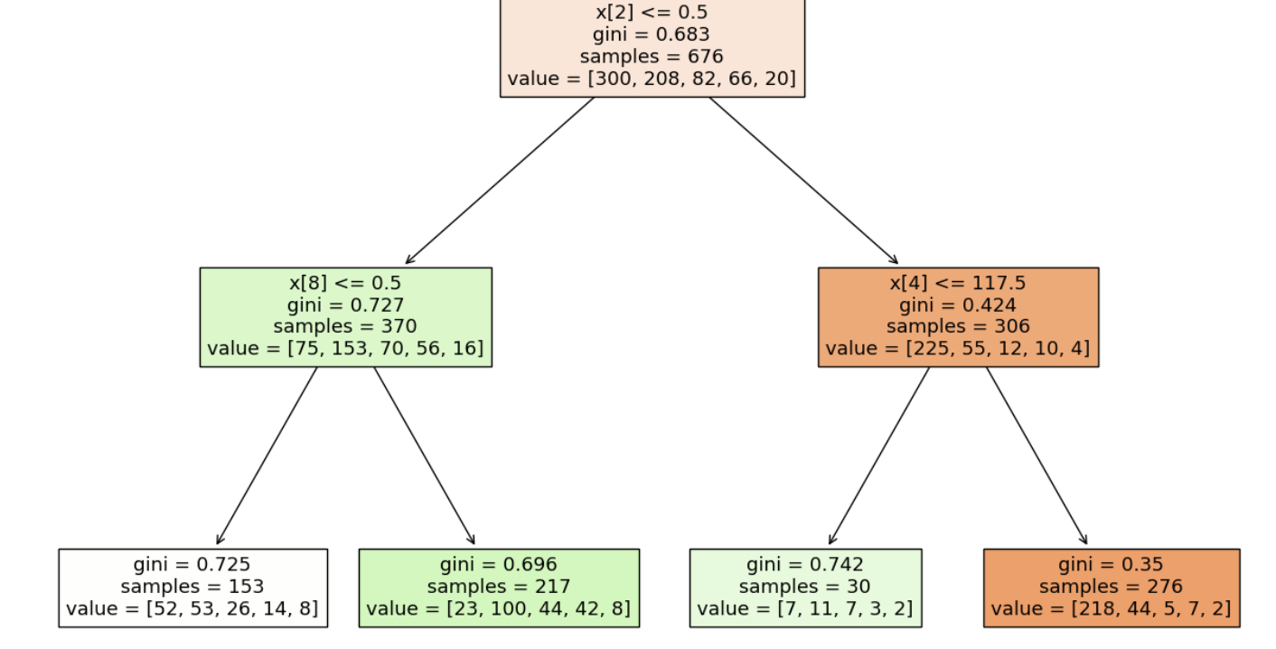

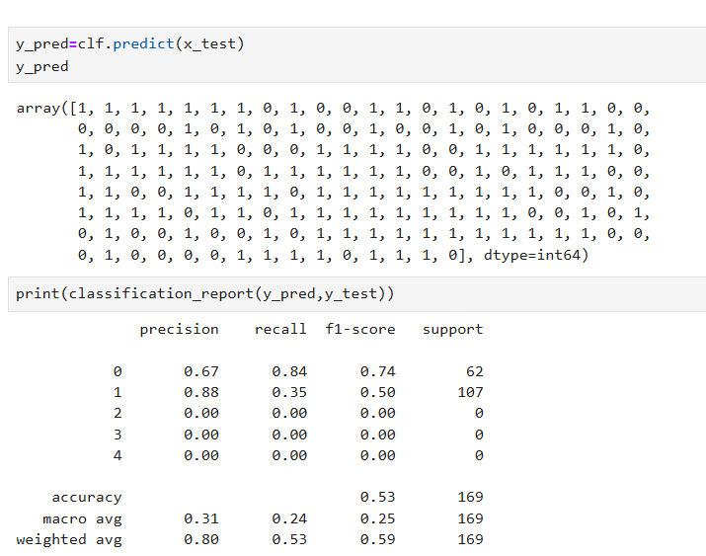

**5. Hyperparameter Tuning:**

Perform hyperparameter tuning to optimize the Decision Tree model. Experiment with different hyperparameters such as maximum depth, minimum samples split, and criterion.

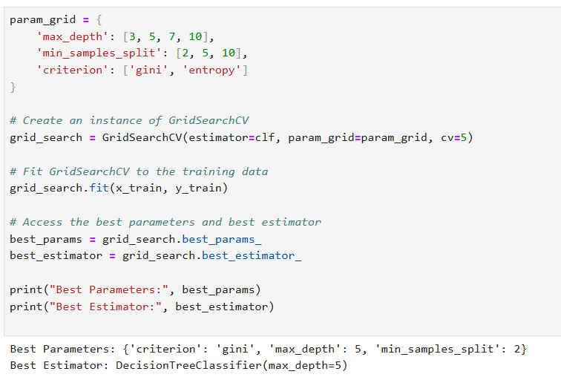

**6. Model Evaluation and Analysis:**

Analyse the performance of the Decision Tree model using the evaluation metrics obtained.

Visualize the decision tree structure to understand the rules learned by the model and identify important features

**Interview Questions:**

1. What are some common hyperparameters of decision tree models, and how do they affect the model's performance?

Answer : Decision trees are powerful and flexible models, and tuning their hyperparameters can significantly impact their performance and behaviour. some of the common hyperparameters for decision tree model are max_depth, min_samples_split,min_ samples_leaf, min_samples_leaf etc..

1. What is the difference between the Label encoding and One-hot encoding?

Answer : **Label Encoding** is often used when dealing with ordinal data where the order of categories is important, or when the machine learning model can handle the ordinal relationship appropriately.

**One-Hot Encoding** is typically preferred for nominal data where there is no inherent order, and especially when using models that assume categorical features are not ordinal.